SELECT *FROM countries

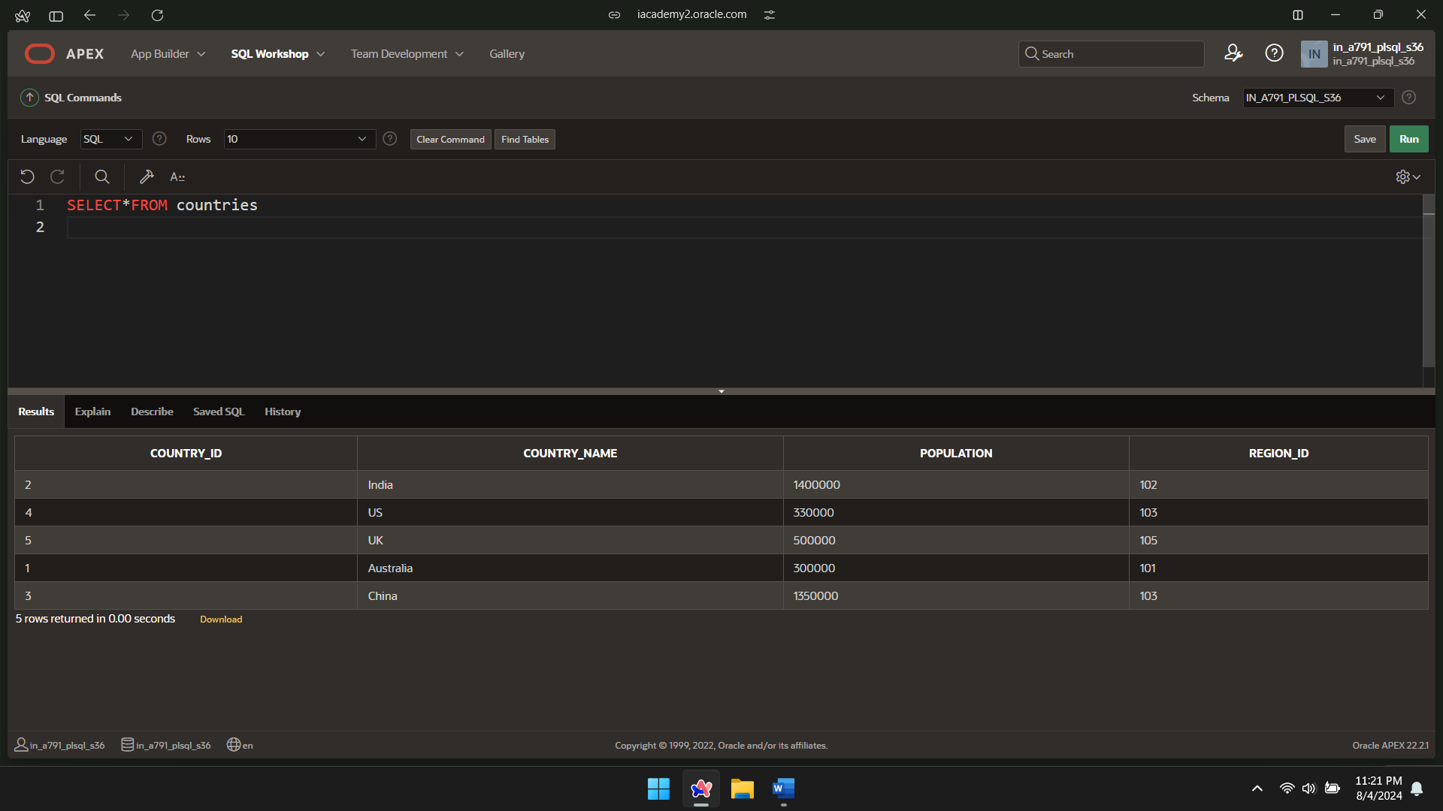

DECLARE

CURSOR cur_countries(p_region_id NUMBER,p_population NUMBER) IS

SELECT country_id, country_name,population

FROM countries

WHERE region_id=p_region_id

OR population>p_population;

BEGIN

FOR v_country_record IN cur_countries(145,1000) LOOP

DBMS_OUTPUT.PUT_LINE(v_country_record.country_id || ' '|| v_country_record.country_name|| ' '||v_country_record.population);

END LOOP;

END;

/

